Michael Mayhew and Daniel Cloran

Computer Science

Mr Spoonmore

25 October 2018

**Problem Statement**

The arcade game that we will be modifying is Joust, a video game released in 1982 on the Nintendo Entertainment System. In Joust, the goal is to survive as long as possible by staying above enemies that are trying to knock the player off of their ostrich. The way that we will be modifying this class arcade game is by remaking it into a two-player dueling game in which two players will fight each other to reach the final score. For this modification, the new goal of the game is to defeat the other player and reach three victories to win the game.

**Criterion A: Planning**

**Design**

The product that is being created is a recreation of the original arcade game, Joust. This product is being created for Mr. Spoonmore, who is the customer of this product. After speaking with the customer, the conclusion was that this project fit the criteria provided. The criteria is: the students are skilled enough with the sufficient programs to create the project; the customer’s hardware and software is compatible with the HTML and Javascript that will be used to complete this product; the data that is required to be able to complete the product is publicly available for the students to find; and the product will cause no security threats. The reason that Joust was the chosen was because Joust is a classic arcade game that we both enjoyed when we were younger. Another reason is because we believe that Joust is an arcade game that would be able to variate in multiple ways.

**Success Criteria**

* The fundamental rules of the Arcade Game Joust are present
  + Two animated players on Ostriches with Lances face off against each other
  + Each player can control movement upwards, left, and right through flapping their ostriches’ wings
  + When a player collides with another player whichever player is lower on the screen dies
  + When a player moves off the left and right of the screen, the player re-appears on the corresponding opposite side
* Two players use 2 unique keyboard button sets to control each ostrich and rider
* Title Screen with five buttons, Start, Controls, High Score, Quit, How to Play
* Rider dies when colliding with another rider at a lower height
* Display a life counter of 3 lives that increments down to 0 as the players die
* Designed player models move upwards when the movement key is pressed
* Designed player models look to the left and right when the related key is pressed
* A Player wins when the other player runs out of lives
* Two scoreboards are present, the scoreboard after each round showing the time the round took and each life counter, and a scoreboard for the high score showing the quickest round
* A sound plays each time a player dies

**Criterion B: Solution Overview**

**Test Plan**

|  |  |  |  |
| --- | --- | --- | --- |
|  | Description of Success Criteria | How to Test | Expected Outcome |
| Success Criteria #1 | The fundamental rules of the Arcade Game Joust are present | Compare between the rulebook of Joust to see if everything that is listed is present in this project | Every rule that is in the original game is present in this reimagination |
| Success Criteria #2 | When a player collides with another player whichever player is lower on the screen dies | Have player 1 run into player 2, being above player 2 the first time then below the second time in order to check player 1 hitboxes work. Repeat for player 2 | The player lower on the screen dies |
| Success Criteria #3 | When a player moves off the left and right of the screen, the player re-appears on the corresponding opposite side | Have player 1 run into both the left and right wall, checking if the player appears on the right and left side respectively. Repeat for player 2 | The player appears on the opposite side of the screen when they reach either side of the screen |
| Success Criteria #4 | Two players use 2 unique keyboard button sets to control each ostrich and rider | Press every button the keyboard to test if they are bound to anything player-related, then press each players’ movement keys to test if they move only the character bound to those keys | Each player has a specific set of buttons that correspond to their actions |
| Success Criteria #5 | Title Screen with five buttons, Start, Controls, High Score, Quit | Check if each button on the start screen leads to its respective canvas | A canvas appears on the first available screen with 5 different buttons that can be pressed |
| Success Criteria #6 | Rider dies when colliding with another rider at a lower height | Have player 1 run into player 2, being above player 2 the first time then below the second time in order to check player 1 hitboxes work. Repeat for player 2 | The player that is above the opposing player defeats the other player when the two collide |
| Success Criteria #7 | Display a life counter of 3 lives that increments down to 0 as the players die | Have player 1 lose three times to player 2 to test the life counter increments down one value each death until it reaches 0, then test with the roles reversed | A life counter on screen iterates down one value each death and does not go below zero |
| Success Criteria #8 | Designed player models move upwards when the movement key is pressed | Press each players movement key to move upwards and test if the character moves in relation to the key pressed | Each player moves upwards when their key for moving upward is pressed |
| Success Criteria #9 | Designed player models look to the left and right when the related key is pressed | Press each players movement key to look horizontally and test if the character moves in relation to the key pressed | Each player looks in the correct direction in correspondence to the key that is pressed. They look left when the left control is pressed and right when the right control is pressed |
| Success Criteria #10 | A Player wins when the other player runs out of lives | Have each player lose to their opposition to test that the player wins when their opposition is out of lives | The game stops when one players’ life counter reaches zero |
| Success Criteria #11 | Two scoreboards are present, the scoreboard after each round showing the time the round took and each life counter, and a scoreboard for the high score showing the quickest round | Check by pressing the high score button on the Title screen to see if one iteration of the scoreboard appears, then have both players lose a game to see if the scoreboard appears after each game | A scoreboard appears after every match that is played and displays the scores of that game  A high score scoreboard is able to be reached through the title screen, revealing the game that ended the quickest and the winner has the most lives available. |
| Success Criteria #12 | A sound plays each time a player dies | Have player 1 and player 2 both die to test if a sound occurs | A noise occurs whenever either player is killed |

**Description of Design Methodologies**

**(Flow Chart at Bottom of File)**

|  |  |  |
| --- | --- | --- |
| **Screen Name** | **Screen Description** | **Screen Display** |
| **Title** | **Displays 5 Choices For Player to Explore** |  |
| **Controls** | **Shows the Controls for Each Player** |  |
| **High Score** | **Shows the game with the fastest time and most lives left for the victor** |  |
| **Scoreboard** | **Shows the score of the previously completed game, including the lives remaining and the time it was completed in.** |  |
| **Game Screen** | **The play area of the Game, the screen where both players face off against each other** |  |
| **How to Play** | **A Description of the Twist on the Classic Joust Arcade Game** |  |

**Player One** - A yellow and blue knight on an ostrich which the User controls.

Idle Orient Left: Idle Orient Right:

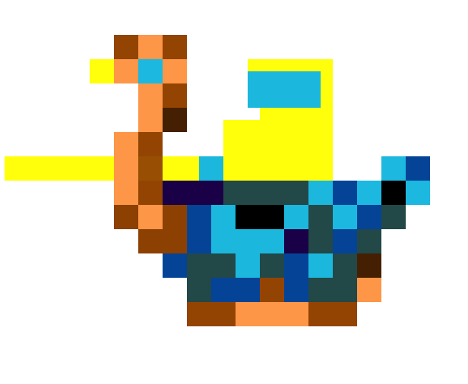 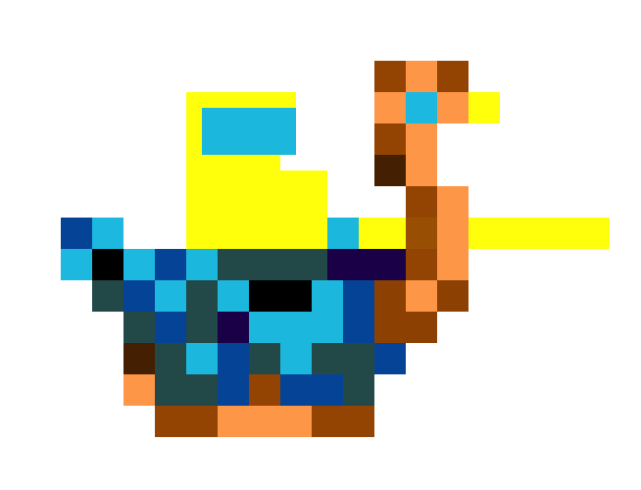

Flap Orient Left: Flap Orient Right:

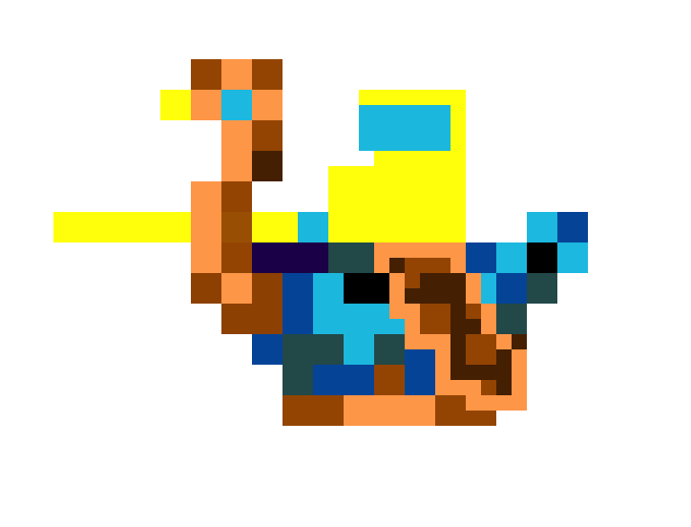 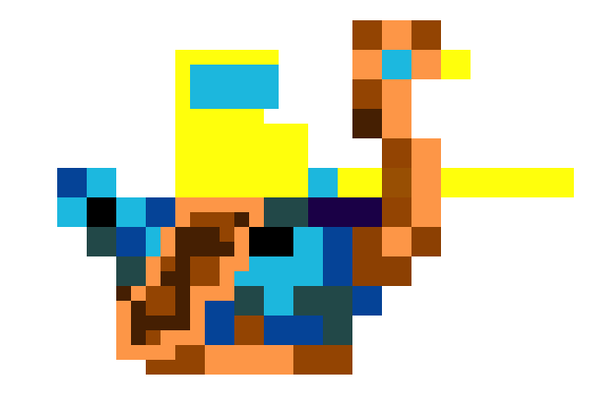

**Player Two** - A green and red knight on an ostrich which the User controls.

Idle Orient Left: Idle Orient Right:

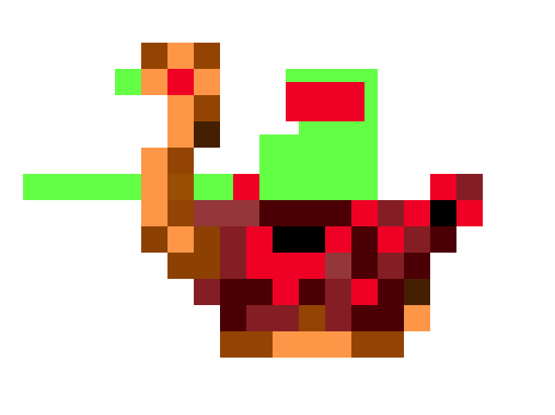 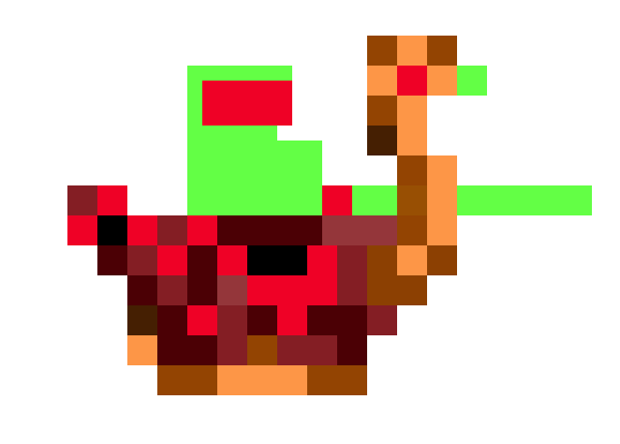

Flap Orient Left: Flap Orient Right:

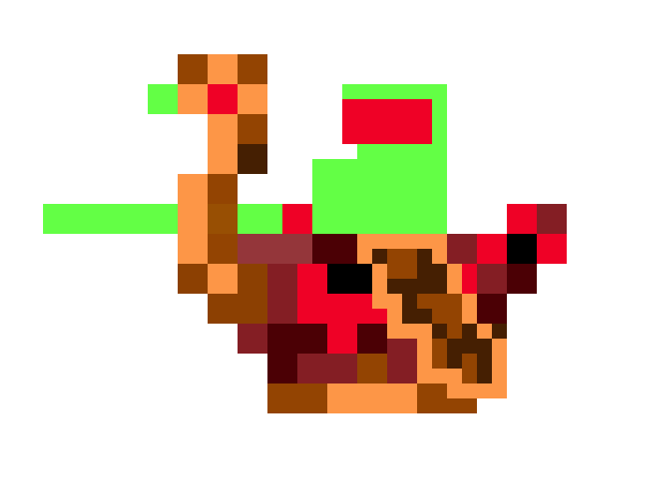 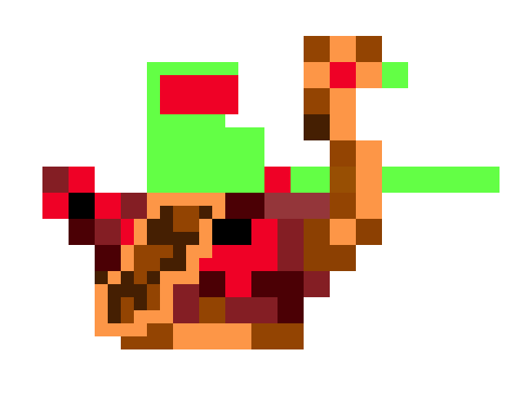

**Task Chart**

|  |  |  |  |  |  |  |
| --- | --- | --- | --- | --- | --- | --- |
| **#** | **Planned Action** | **Planned Outcome** | **Time Estimate** | **Target Completion Date** | **Criterion** | **Person** |
| **1** | **Design Work and Sketchups** | **Designed Screens and Sprites Built for Game** | **1 day** | **October 25th** | **Drawing out the 5 different screens of the program as well as the 2 players and each animation form of each player.** | **Michael**  **Daniel** |
| **2** | **Developing Controls of Each Player** | **Two separate players controlled with 3 unique buttons each** | **3 days** | **October 28th** | **Creating control sets for both characters, determining flight animation, and adding movement to sprites.** | **Daniel** |
| **3** | **Developing Collision between Players** | **Two players who when colliding, the player that is lower vertically is killed** | **3 days** | **October 28th** | **Determining whether two characters are colliding, and determining a winner** | **Michael** |
| **4** | **Develop all Screens with buttons** | **Five unique buttons each with an integrated path to their respective screens** | **2 days** | **October 31st** | **Each button leads to a new screen that is directly related to the button pressed. From the screen a quit button is available** | **Michael** |
| **5** | **Develop Timer to begin rounds** | **A five second countdown to begin each round** | **2 days** | **October 31st** | **At the start of each round displaying a countdown of 5 seconds to let the players know when to begin.** | **Daniel** |
| **6** | **Updating Score Screen at the end of each round** | **A scoreboard is displayed at the end of each round, and is updated based on the victor of the previous round** | **2 days** | **November 2nd** | **A scoreboard appears that has the details of the previous round, including the lives left for each player and the time taken to complete the round.** | **Michael** |
| **7** | **Updating and displaying High Score values** | **A High Score screen to display the data from quickest time any Jouster has been defeated.** | **2 days** | **November 2nd** | **Keeping track of the data and time each round determining which is the lowest and displaying it in the High Score screen** | **Daniel** |
| **8** | **Death Sound and Respawn Point** | **A sound plays when two players collide, then both players respawn** | **2 days** | **November 4th** | **Determining correct sound to player when a player dies, as well as resetting the round and player spawn points** | **Daniel** |
| **9** | **Developing Playing Screen** | **When a player goes off the screen horizontally the player appears on the other side, keeping the same momentum. The player will also bounce off the ceiling downwards.** | **2 days** | **November 4th** | **The screen must be the custom image that was created for the game, with that area being the playing field. It also must have borders on the left and right sides, that when hit, teleport the player to the opposite side from the one that was interacted with.** | **Michael** |
| **10** | **Evaluating Effectiveness of Project** | **A report written with all of Criteria D addressed** | **1 day** | **November 5th** | **Looking back through Success Criteria, scope and project plan and evaluating progress and Version 2.0** | **Michael**  **Daniel** |

**Flow Chart**

